HDS v2.0 Compliance for Log360
Tagline: Support French health data hosting compliance with log monitoring and security reporting from Log360.

Overview
The HDS v2.0 (Health Data Hosting Certification) Compliance extension for Log360 helps French health data hosting service providers meet the security monitoring, access audit, and incident management requirements of the ANS-supervised HDS certification framework.
Log360 collects and analyzes logs from health data infrastructure, cloud platforms, identity systems, and network devices, providing security teams with visibility into access to sensitive health data and system integrity events. Compliance teams can demonstrate control adherence and generate audit evidence for HDS certification audits conducted by accredited certification bodies.

Key Features
- Generate predefined HDS v2.0-aligned audit reports covering health data access events, user authentication, system changes, and security incident monitoring.
- Monitor access to hosted patient health data and detect unauthorized queries, data transfers, and privilege escalations across health hosting infrastructure.
- Configure real-time alerts for HDS-critical security events such as unauthorized health data access, audit log tampering, and anomalous administrative actions.
- Export compliance evidence in PDF and CSV formats for HDS certification audits, ANS reporting, and internal health hosting governance reviews.



Screenshots
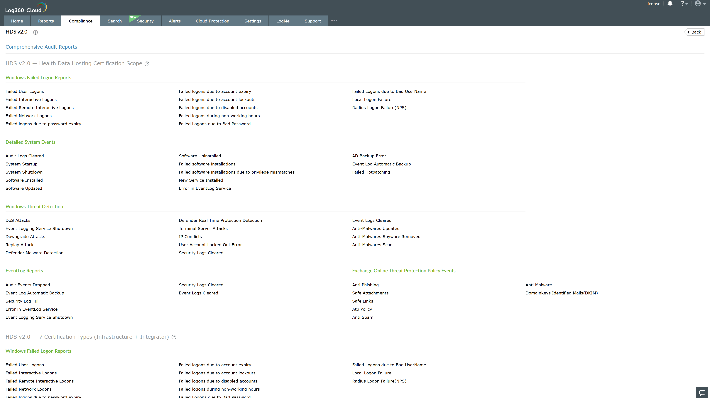
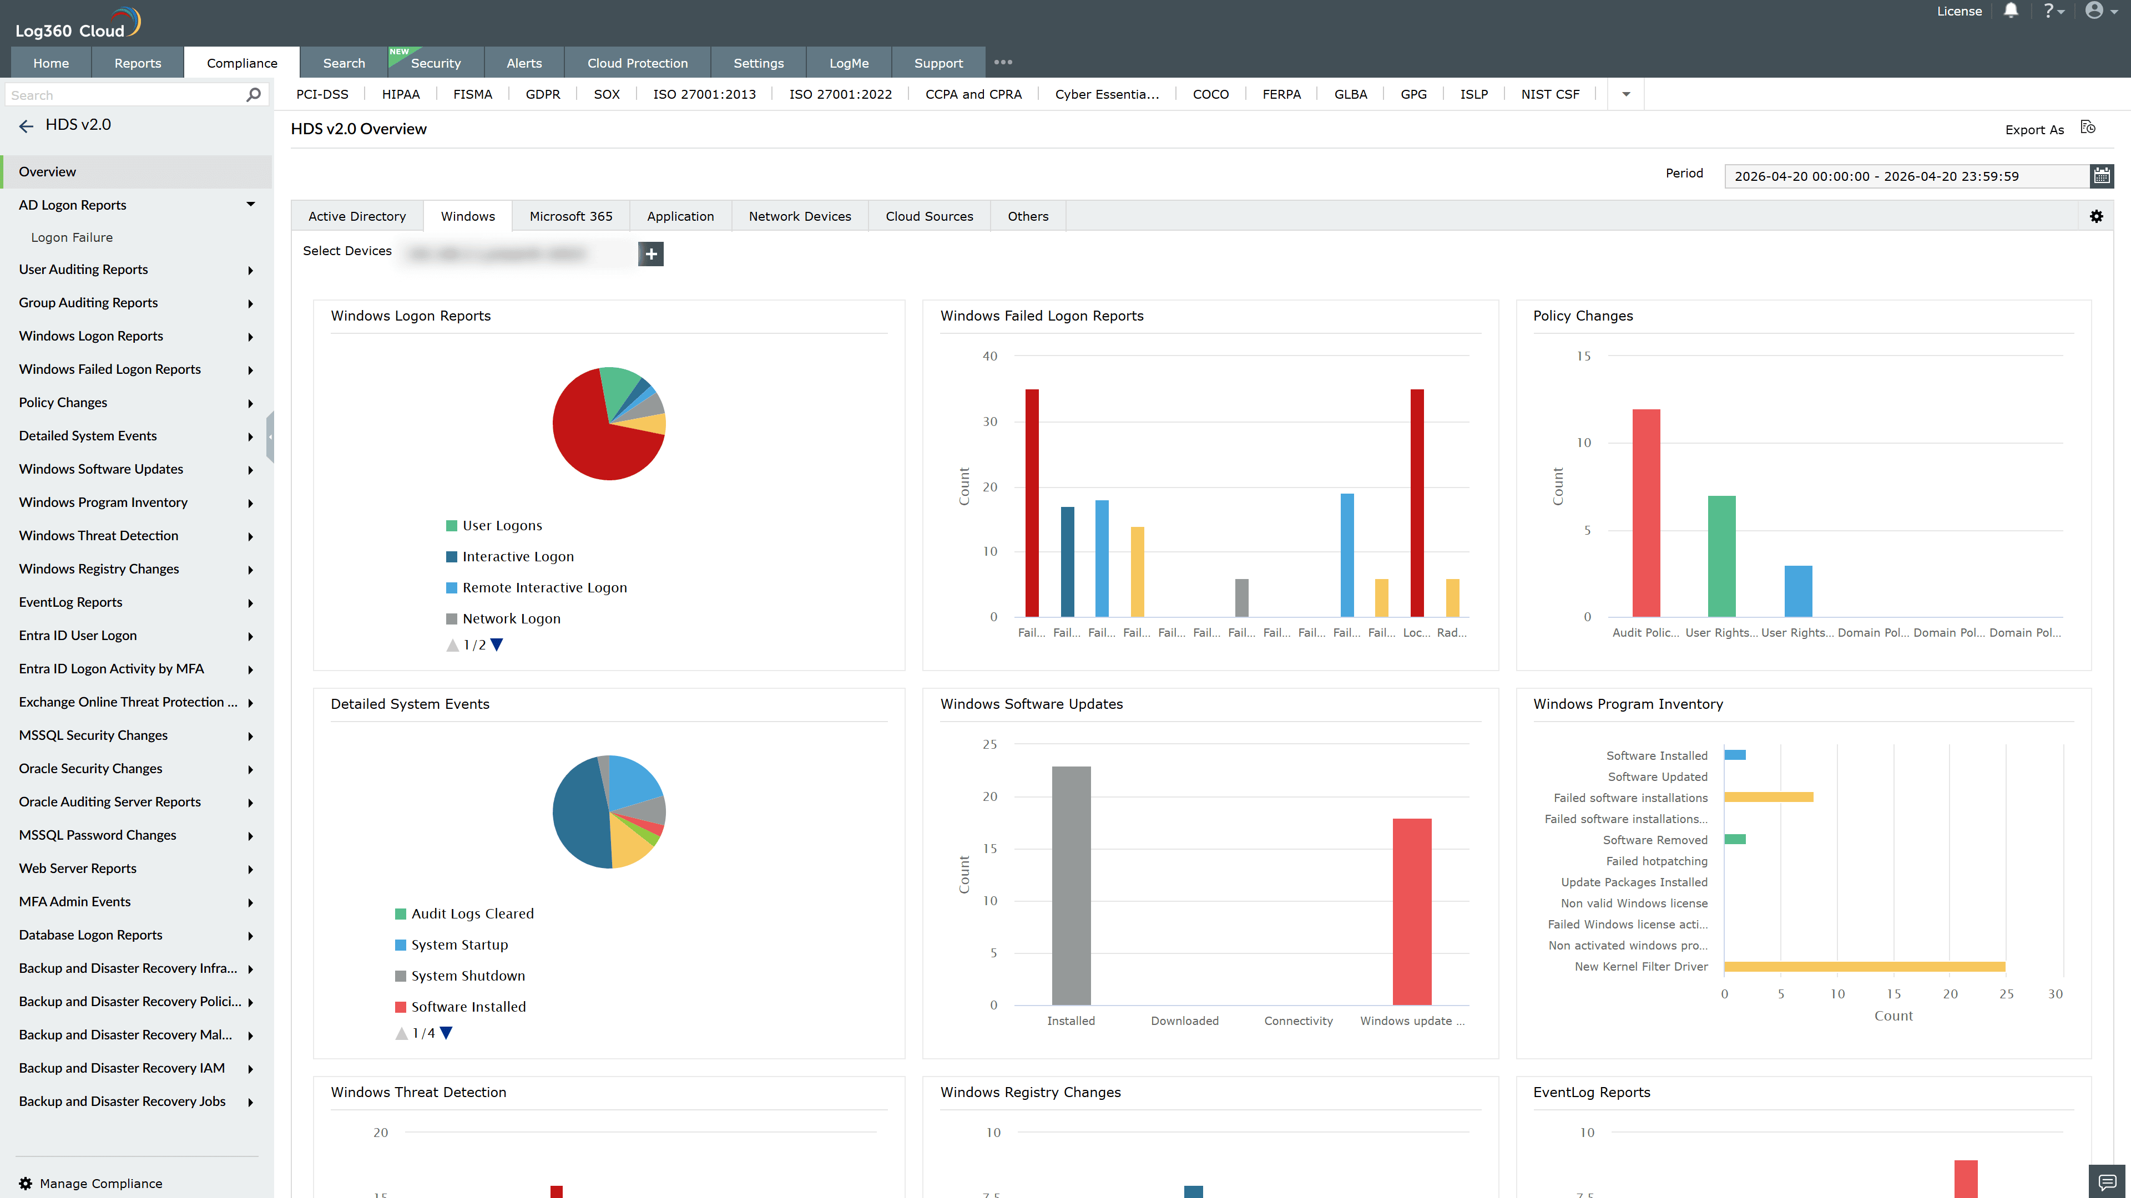
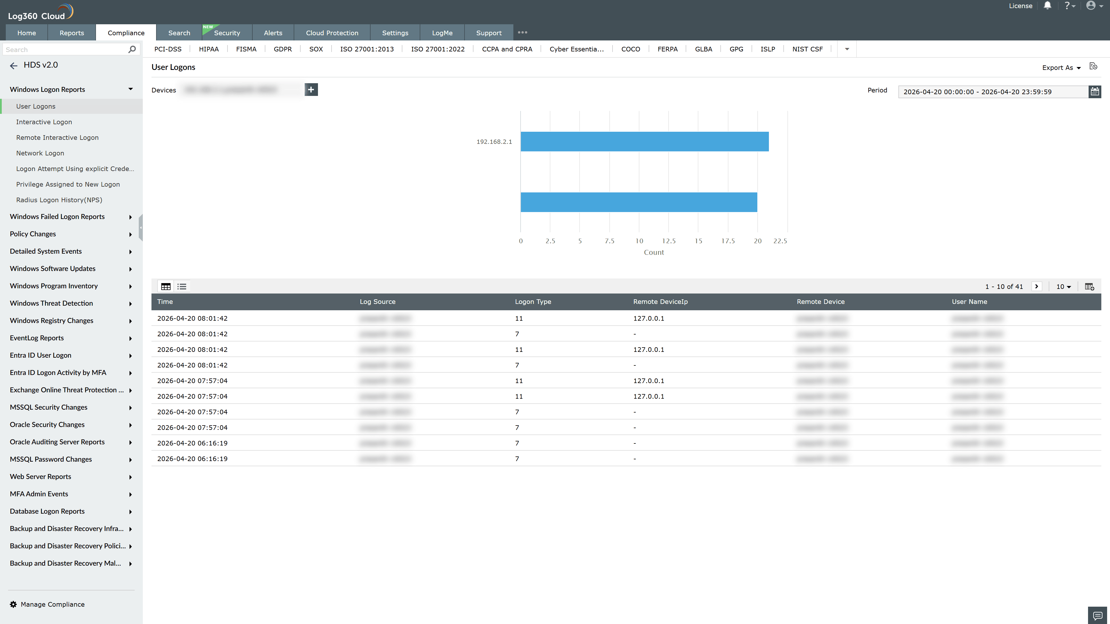
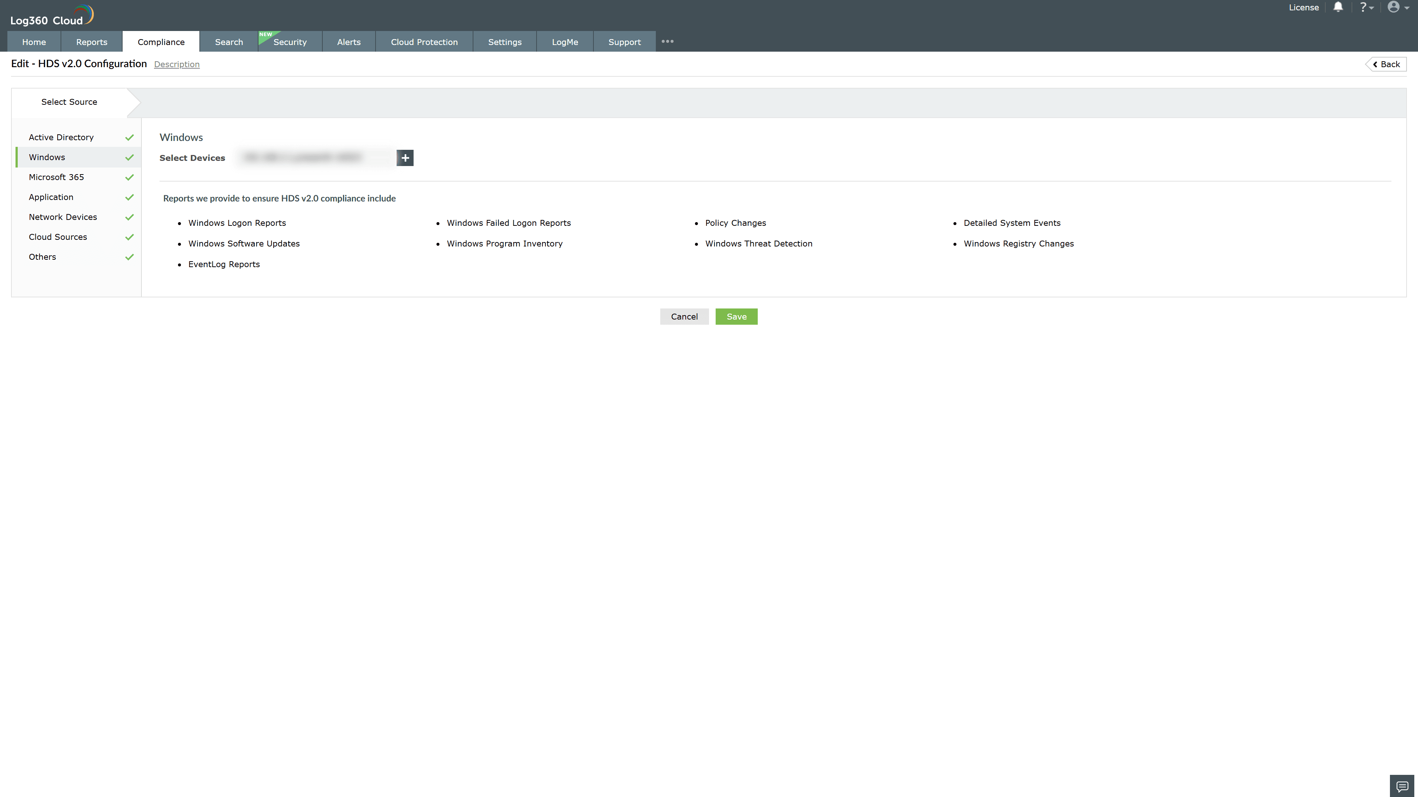

Valid Submission : Yes
Supported Editions : Free, Basic, Standard, Professional, MSSP
Help Document : https://www.manageengine.com/log-management/help/integrations/compliance-extensions.html
Help Video : Not provided
Tags : Log360, Compliance, Privacy monitoring, Data privacy, Regulatory compliance
Supported DCs : US, IN, JP, CA, AU, UK and EU
Privacy Policy:
Terms of Service:
Release Notes:
Predefined reports for the HDS v2.0 Compliance

